https://www.jdoodle.com/embed/v0/6bwN
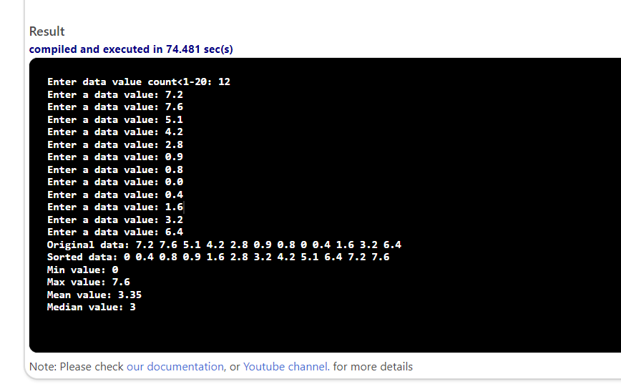
#include <iostream>
#include <algorithm>
using namespace std;

void input(double x[], int length);
void display(double x[], int length);
void copy(double source[], double dest[], int length);
void sort(double x[], int length);
double min(double x[], int length);
double max(double x[], int length);
double mean(double x[], int length);
double median(double x[], int length);

int main()
{
const int MAX_ITEMS = 20;
double data[MAX_ITEMS], sdata[MAX_ITEMS];
int dataLength;

cout << "Enter data value count<1-20: ";
cin >> dataLength;

if (dataLength > MAX_ITEMS)
{
cout << "Error: too many items!" << endl;
return 1;
}

input(data, dataLength);

copy(data, sdata, dataLength);
sort(sdata, sdata + dataLength);

cout << "Original data: ";
display(data, dataLength);

cout << "Sorted data: ";
display(sdata, dataLength);

cout << "Min value: " << min(sdata, dataLength) << endl;
cout << "Max value: " << max(sdata, dataLength) << endl;
cout << "Mean value: " << mean(sdata, dataLength) << endl;
cout << "Median value: " << median(sdata, dataLength) << endl;

return 0;
}

void input(double x[], int length)
{
for (int i = 0; i < length; i++)
{
cout << "Enter a data value: ";
cin >> x[i];
}
}

void display(double x[], int length)
{
for (int i = 0; i < length; i++)

{
cout << x[i] << " ";

}

cout << endl;
}

void copy(double source[], double dest[], int length)
{
for (int i = 0; i < length; i++)

{
dest[i] = source[i];
}

}

void sort(double x[], int length)
{
std::sort(x, x + length);
}

double min(double x[], int length)
{
return x[0];
}

double max(double x[], int length)
{
return x[length - 1];
}

double mean(double x[], int length)
{
double sum = 0;
for (int i = 0; i < length; i++)

{
sum += x[i];
}
return sum / length;
}

double median(double x[], int length)
{
if (length % 2 == 0)
{
return (x[length / 2 - 1] + x[length / 2]) / 2;
}
else
{
return x[length / 2];
}
}

